# **Name: Abdurrahman Qureshi**

# **Roll No: 210451**

Practical No: 6

1) Sum of all items of a list

CODE:

myList = [83, 45, 73, 22, 85, 94]  
sum = 0  
for i in range(len(myList)):  
 sum += myList[i]

print("sum of the elements of the list =", sum)

OUTPUT:

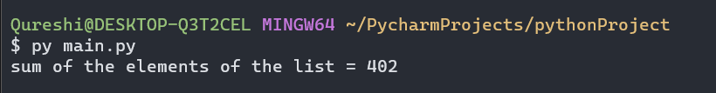

2) Product of all items of a list

CODE:

myList = [83, 45, 73, 22, 85, 94]  
sum = 1

for i in range(len(myList)):  
 sum *= myList[i]

print("sum of the elements of the list =", sum)

OUTPUT:

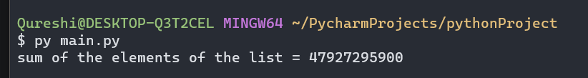

3) Find largest and smallest from a list

CODE:

myList = [83, 45, 73, 22, 85, 94]  
largest = myList[0]  
smallest = myList[0]  
for i in range(len(myList)):  
 if myList[i] > largest:  
 largest = myList[i]  
 if myList[i] < smallest:  
 smallest = myList[i]  
  
print(largest)  
print(smallest)

OUTPUT:

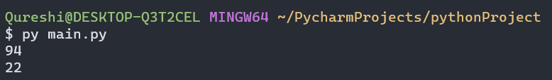

4) Reverse a list

**CODE:**

myList = [83, 45, 73, 22, 85, 94]  
print(myList)  
  
myList.reverse()  
print(myList)

**OUTPUT:**

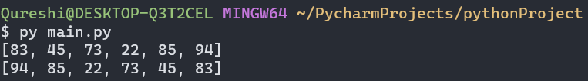

5) Find common from two lists

**CODE:**

myListA = [83, 45, 73, 22, 85, 94]  
myListB = [87, 45, 71, 92, 85, 98]  
print(myListA)  
print(myListB)  
myListC = list()  
for i in range(len(myListA)):  
 if myListA[i] in myListB:  
 myListC.append(myListA[i])

print(myListC)

**OUTPUT:**

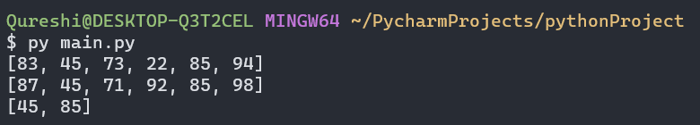

6) Print even numbers from a list

**CODE:**

myListA = [83, 45, 73, 22, 85, 94]  
print(myListA)

for i in range(len(myListA)):  
 if myListA[i] % 2 == 0:  
 print(myListA[i])

**OUTPUT:**

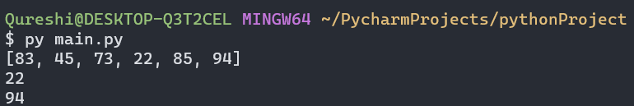

EXTRA QUESTIONS

1) Reverse via loops

**CODE:**

myListA = [83, 45, 73, 22, 85, 94]  
print(myListA)  
myListB = list()  
for i in range(len(myListA) - 1, -1, -1):  
 myListB.append(myListA[i])  
print(myListB)  
print(fact)

**OUTPUT:**

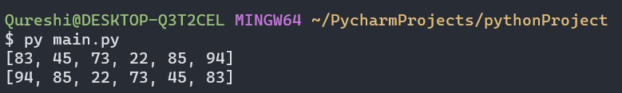

2) Pop the given index

**CODE:**

myListA = [83, 45, 73, 22, 85, 94]  
print(myListA)  
removeIndex = 3  
myListA.pop(removeIndex)  
print(myListA)

**OUTPUT:**

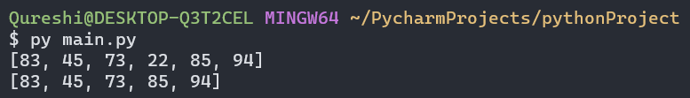

3) Sort in ascending and descending order

**CODE:**

numOfItems = int(input("Enter list length: "))  
myListA = list()  
for i in range(1, numOfItems + 1):  
 x = int(input("Enter element " + str(i) + ": "))  
 myListA.append(x)  
print(myListA)  
print(sorted(myListA))  
print(sorted(myListA, reverse=True))

**OUTPUT:**

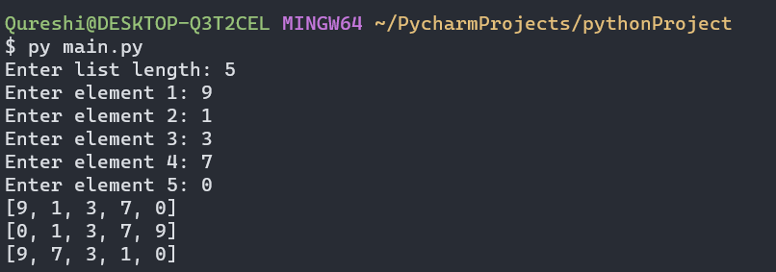

4) Insert at user’s index

**CODE:**

myListA = [83, 45, 73, 22, 85, 94]  
print(myListA)  
myIndex = int(input("Enter index: "))  
myVal = int(input("Enter value: "))  
myListA.insert(myIndex, myVal)  
print(myListA)

**OUTPUT:**

